Engr421 HW-2

Discrimination by Regression

Doğukan Soyuyüce

69331

***Objectives of the homework :***

We are given a real life dataset and asked to implement a classification algorithm which uses the sigmoid function learned in lab3 . We use sigmoid , instead of softmax, because in this case we have non-mutually exclusive(non-overlapping) dataset . I used sigmoid function with OVA perception. If we implement the sigmoid function to our algorithm rule , we would have high class probabilities.

***1-)*** I firstly divided the given dataset consists of 195 data points into test and train sets. Secondly I turned my pandas dataframe datasets into numpy array , in order to be able to use them in my algorithm and multiplications. 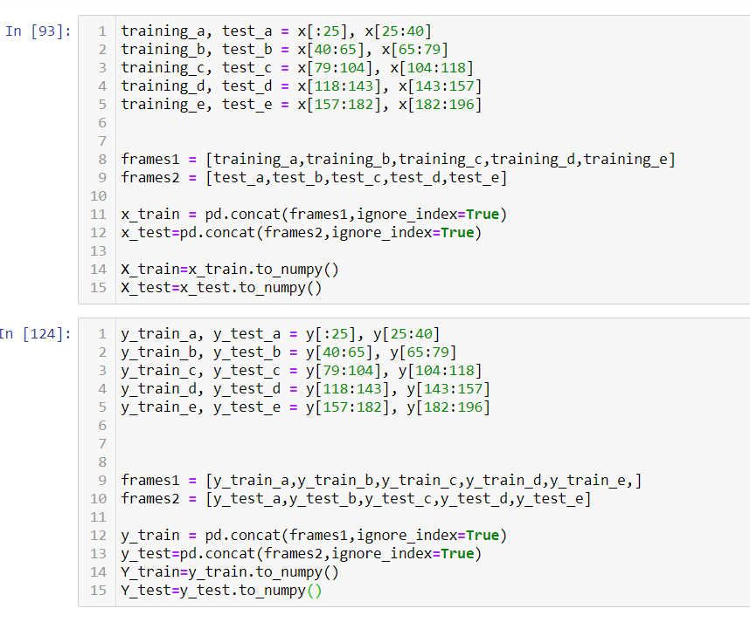

***2-)*** For my algorithm , I used my sigmoid function -we used sigmoid because we don’t have a mutually exclusive data(we would use softmax if we had) . Since we have a multi-label classification problem , I used sigmoid function for each raw independentely. Sigmoid allow us to have high probability for our classes. - for my y_predicted set , and I used gradient formulas for learning the algorithm until my iteration breaks.

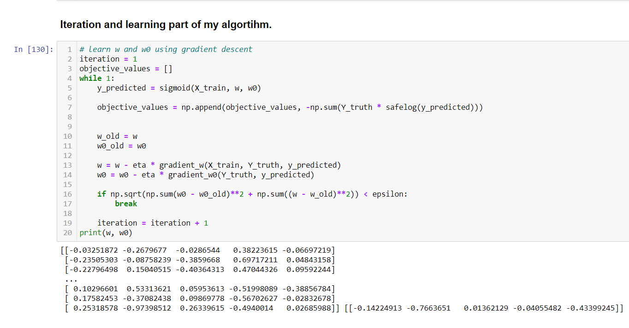

***3-)*** I plotted my errors using iterations.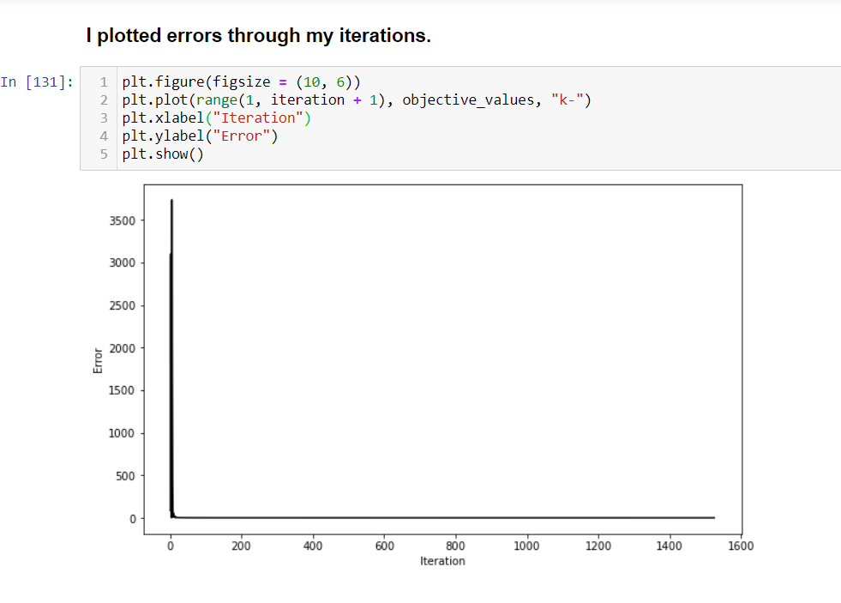

***4-)*** Finally , I calculated my confusion matrices for train and test sets using the classification rule I developed using w and w0 parameters.

